Welcome to Pangbourne Valley Playgroup!

The following outlines some of the policies we have in place at Pangbourne Valley Playgroup, and general information we think you might find useful.

SESSIONS AND PAYMENT

Session Times:

Playgroup is open from Monday to Thursday in term time, excluding Bank Holidays.

In September 2020 due to the global pandemic our hours will be temporarily changed to 9.15am to 2.55pm to allow for staggered drop off times alongside Pangbourne Primary School. This is a temporary measure, and when the hours change back to normal, we will notify parents with plenty of notice.

We offer two standard sessions with the duration of 2 ½ hours each, and a lunch club in between them:
Morning Session from 9.15am to 11.30am on Monday to Thursday.
Lunch Club from 11.30am till 12.45pm on Monday to Thursday.
Afternoon sessions from 12.45pm to 2.55pm on Monday to Thursday.

We hope to resume our normal sessions of 9am until 3.15pm as soon as possible. We also hope to reopen our Friday sessions when the demand is greater. We will keep parents informed of any changes to the hours over the next weeks.

Guidelines now stipulate that having children in more than one venue is allowed and as such we will be doing our pick up from FS1 as normal at 12pm. For those attending FS1 and coming at lunch club please bring a packed lunch to Pangbourne Primary in the morning and have your child bring it with them from FS1 to playgroup.

Drop off and Pick up:

- Drop off: Parents/carers will drop off and pick up at the gate.

- Pick up: It is important to collect your child promptly at the end of the session (11:30am, 12:45pm or 2:55pm). It can be very upsetting and stressful for a small child to be the only one who is not collected. A child can be collected only by the assigned person. If someone new is collecting your child, please ensure we know in advance, so we can set up a password for collection. If your child will be regularly collected by that person, please ensure we know so we can expect him/her on that day.

- Parking: If driving in, please park in the circle outside the school gates or on Kennedy Drive. Parents/carers are requested not to drive into the school grounds or park in the lay-by on Reading Road. The school car park operates a permit system for their staff, as they are seeing an increase of parents using the school staff car park. If you or your child has a disability, please see Mrs Fry at the school so that you can be issued with a permit too.

Parents will need to queue at the gate for both drop off and pick up and ensure that they are socially distancing from other parents while doing so.

Term Time:

We follow the West Berkshire term holidays and in general, will be closed whenever the school is closed.
There are 3 semesters/6 terms in our academic year;
Semester 1 : Autumn 1st term + Autumn 2nd term
Semester 2 : Spring 1st term + Spring 2nd term
Semester 3: Summer 1st term + Summer 2nd term

Term Dates:

This year’s term dates are as follows. These dates are maintained by West Berkshire here: https://info.westberks.gov.uk/termdates

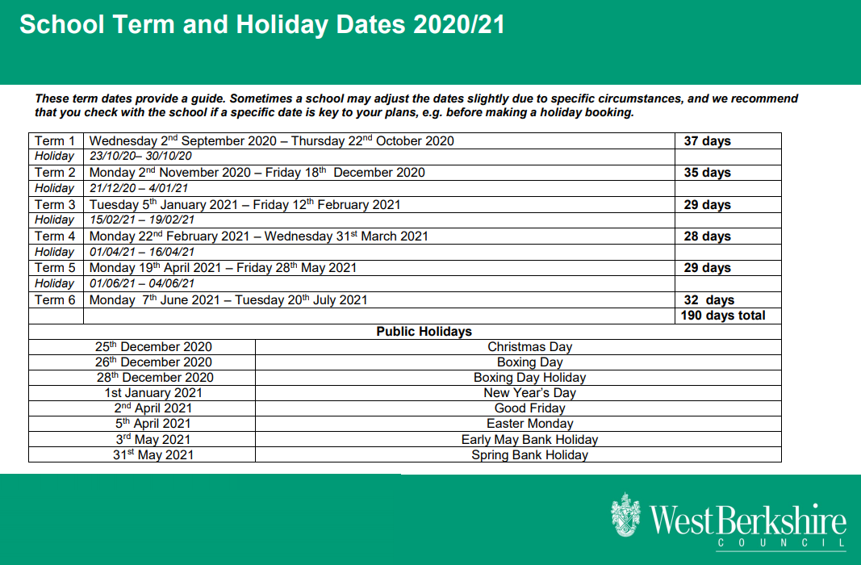

Fees and Payment information:
We bill 6 times a year, lining up with each term. You will receive an invoice a few weeks into the term, which will cover that term’s payment based on the sessions you currently have, or are booked to receive during that term.

You will have 2 weeks to pay this invoice. If you feel you can not pay within this timeframe, please contact the treasurer to make alternative arrangements.

We accept Childcare vouchers from most providers, but please contact us in advance when organising payment for the first time, as any new providers we don’t currently support can take time to set up.

STANDARD SESSION | Fees for session
9.15am-11.30am Morning Session | £14.50
11.30am-12.45pm Lunch Club | £7.25
12.45pm-2.55pm Afternoon Session | £14.50

Free Childcare:
The term following your child’s 3rd birthday they become eligible for a government funded Nursery Education Grant. PVPG will apply on your behalf when your child is eligible, and provide a form for you to complete and sign. The grant is paid directly to PVPG by West Berkshire Local Authority and currently provides for up to 15 hours “free” nursery education per week. We are now also registered to apply for the new 30 hours funding if you are eligible. Please speak to the Treasurer /Staff if you require this.

Amendments to sessions:
If you wish to change any sessions, whether adhoc or as a permanent change, please email pvpg.enquiries@gmail.com to request the amendment. Please give us as much notice as possible for amendments, especially additional sessions.

We have a maximum allowance of 20 children in playgroup for a session. In addition, while we may have spaces for more children in a given slot, we need to ensure we have staff to cover the ratios needed for the children at hand.
Often an additional session request can result in requiring more staff to cover that session, which can take some time to organise. In cases where we can not offer a requested session, for whatever reason, we will operate a waiting list until the session becomes available.

If you wish to cancel a session, you must give 2 weeks notice of the cancellation.
If you wish to leave playgroup completely, you must give 4 weeks notice of the cancellation.

Absence and closure:
If your child is absent from playgroup due to illness or holiday, you will still be billed for that session.
If the playgroup needs to close for reasons such as inclement weather, you will still be billed for that session.

Illness:
Please do not send your child to Playgroup if they are unwell, particularly with a high temperature, sore throat, heavy cough or cold, sickness and diarrhoea, impetigo or conjunctivitis and allow a clear 48 hours before returning.

If your child has any symptoms of COVID they must not attend playgroup. They must self isolate for 14 days and/or be tested to confirm whether they have COVID.

Also please notify Playgroup as soon as possible if your child contracts an infectious disease such as chicken pox, measles or mumps. We will then confirm the minimum isolation period and return date.

AGM:
Our AGM occurs in November each year. Parents are required to attend the AGM. The date of the AGM is circulated in October.

CLOTHING AND BELONGINGS:

Belongings: In the entrance lobby each child has a labelled coat peg with a shoe locker below, as well as a paperwork drawer. Please check this drawer regularly for communication from us and your child’s artwork to take home.

Footwear: Please bring indoor footwear (slippers or shoes) and outdoor footwear (shoes or wellies) as the playground can be wet and muddy. Please can all footwear be named.

Clothes: A change of clothes is always useful, particularly if your child has recently potty trained, although we do have spares for emergencies. Please leave in a labelled bag on their peg and provide enough nappies or pull-ups if needed by your child. In summer we ask that children bring named hats to wear during outside play.

PVPG shirts: We have Playgroup Valley t-shirts for sale in various sizes and colours at playgroup. The money for these t-shirts goes towards fundraising for the playgroup. If you are interested in the t-shirts please ask the staff about them.

Labelling: Please ensure all belongings are named, particularly footwear, coats/jackets and lunch boxes to help us and ensure they don’t get lost.

FOOD:

Lunch Club: If your child attends lunch club, please provide a packed lunch in a suitable bag or box with an ice-block as we do not have enough fridge space. Please pack a healthy lunch with a drink and we will try to ensure your child eats well (one tip is to get your child to decide some of the contents such as what filling in the sandwiches or which type of fruit/yoghurt etc goes in.) On arrival, lunch boxes should be placed on the table inside the door.

Snack time: Please bring some healthy snacks for your child to eat at nursery. We normally have a snack time at 10.00 and 2.00.

Please ensure for both lunch and snacks that the food is cut up appropriately eg grapes and tomatoes should be slice in half, olive and cherries should be pitted etc

If your child has any particular dietary requirements, please ensure we know.

Please be aware we have children who attend Playgroup and Staff with allergies. Please ensure that
lunch boxes DO NOT contain any products that have nuts in them.

EMERGENCY CONTACT DETAILS UPDATE:

Always ensure the Playgroup has up to date emergency contact details, particularly your mobile phone numbers. We hope never to use them but we may need to contact you urgently while your child is in our care. If you need to update these details, please email into pvpg.enquiries@gmail.com so we have a record of the change.

CONTACT WITH STAFF/KEY PERSON:

The staff are happy to discuss your child’s progress with you at any time but we also organise a parent /key person meeting each term. We will send out details of this via email during the term.

Tapestry: We use tapestry to record pictures and observations of your child. Please remember to check in and see what they are up to. We also love to see the observations and images you upload of your life at home.

PVPG WEBSITE AND SOCIAL MEDIA:

We have a fantastic website that includes lots of information about PVPG, including details about what the children do and learn at playgroup, our newsletters and photos.
http://www.pvpg.org.uk/

We also have a private facebook group for parents and carers that has pictures of playgroup activities we set up, notices for parents for upcoming events etc. To find the group please search for : Pangbourne Valley Playgroup for Parents and Carers or click on https://www.facebook.com/groups/1448427242080683/

We also have a newsletter that we send out to keep you up to date on goings on at playgroup.

PANGBOURNE VALLEY PLAYGROUP (PVPG) PARENTS COMMITTEE:

We are a registered charity and are run by a committee of parents. We encourage every parent to get involved in some way, preferably by joining the committee or by helping out with fundraising. Each year in the Autumn Term there is an Annual General Meeting that all the parents are asked to attend, where the committee reviews the year and elects replacements for any departing committee members. Without the parents committee the playgroup cannot run – please come and meet us at the next committee meeting.

FUNDRAISING (which may pause due to COVID):

We would ask that Parents donate £30 to playgroup for materials and arts and crafts each year. This can be done via a cash donation or via BACS transfer. Please ask staff for details.

We regularly have fundraising events organised by Playgroup. These help to raise much needed money to provide materials and fun activities for the children, and to pay for bigger items such as refurbishing the playgroup etc.

Event | Description | When is it on | How can you help?
10k | Help support the 10k race at the school. | Early September | Help man the stand for glitter tattooing etc.
Mystery Photo Trail | Photo hunt around the village | October Half Term | Buy a sheet in Garlands and take part in the hunt
FOPPS Fireworks | November | Early November near Guy Falk’s night | Help man the stand for glitter tattooing etc.
Christmas Craft | Designed by staff | Autumn Term 2 | Buy your Christmas cards, gift tags and wrapping paper that your child has designed.
Christmas Raffle | 10 donated gifts/days out etc as prizes | Autumn Term 2 | Donate gifts/prizes for raffle. Sell raffle tickets to friends/family.
Pamper evening | Pamper evening in a local venue where you can get massages/facials/manicures | February | Come and get pampered
Duck hunt | 20 little ducks hidden around the village looking to be found by your little ducklings. | Easter | Buy a sheet in Garlands and take part in the hunt
Village Fete | Stand at the fete running a bottle tambola, face painting, glitter tattooing | June | Donate sweets/money for jars. Volunteer to help man the stall, help set up/pack up.
Garden Party | Buffet lunch for children with a stand for glitter tattoos, face painting etc. | July | Donate food for lunch. Help man the stand.

Please speak to a member of staff or committee if you wish to be involved or email the usual playgroup email address.
PRIVACY NOTICE:
We will adhere to the principles of the General Data Protection Regulations (2018) when collecting and processing information about you and your child. We explain how your data is processed, collected, kept up-to-date in our Privacy Notice which is available on our website or by clicking here : http://www.pvpg.org.uk/wp-content/uploads/2016/11/PVPG-Privacy_Notice-PVPG.pdf

ADDITIONAL POLICIES:
Our policies are available on our website at http://www.pvpg.org.uk/about-pvpg/

We hope this letter has been useful, if you have any further urgent queries please call Sam at the Playgroup on 0118 984 1661.

